
MSc Computing Research
“Building an ML-based Ensemble Model for Fraud Detection in Digital Banking Transactions”

Project Report
This dissertation does NOT contain confidential material and thus can be made available to staff and students via the library.
Student Name | LALI MANIKANTA GOWRISETTI
Student ID | 35054253
Supervisor | Dr. JUMOKE POPOOLA
Date of Submission | SEPTEMBER 10, 2026

This dissertation IS CONFIDENTIAL and circulation should be
restricted to those involved in its assessment only.

Acknowledgements
I would like to thank my supervisor for the guidance, feedback and academic support provided throughout this project. And I also acknowledge Sheffield Hallam University for providing the academic resources and learning environment required to complete the research.

Abstract
This project aims to create and test an ensemble model for fraud detection in digital banking transactions using machine learning techniques, specifically focusing on enhancing the effectiveness of fraud detection and minimizing false positives. Secondary data was used and quantitative/computational approach was taken. The Bank Account Fraud dataset from NeurIPS 2022 was used with Python and comprised of almost one million anonymised records and 30 features. A 70/30 stratified split was used and only SMOTE was applied to the training data to mitigate severe class imbalance. To use as baseline classifiers, Random Forest and XGBoost were used, and a Stacking Ensemble was used to stack these classifiers with Logistic Regression as a meta-classifier. For the performance, precision, recall, F1-score, AUC-ROC, false-positive rate and computational latency were used. The Base-dataset results for XGBoost were the best with an F1-score of 0.0576 and AUC-ROC of 0.8441 whereas the results of the Stacking Ensemble were 0.0546 and 0.7838 respectively. The ensemble maintained measurable performance with the changes of the variant datasets, as shown by the robustness testing performed on five variant datasets, with the highest F1 score of 0.1250 on Variant II. The results overall show the usefulness of comparative ensemble evaluation and point to some recalls and computational inefficiencies.
Table of Contents
1. Introduction 6
1.1 Research Background 6
1.2 Research Rationale 6
1.3 Research Question 6
1.4 Research Aim 7
1.5 Research Objectives 7
2. Literature review 8
2.1 Tools for Literature Review 8
2.2 Input Search Queries 8
2.3 Results from Search 8
2.4 Rationale for choosing literature review themes 11
2.5 Course of Action 12
2.6 Literature Gap 12
2.7 Contrasting and Conflicting Views 13
3. Research Methodology 14
3.1 Introduction 14
3.2 Research Methods and Strategy 14
3.3 Machine Learning Development Methodology 14
3.4 Model Requirements and Performance Criteria 14
3.5 Ensemble Model Design 14
3.6 Model Development and Implementation 14
3.7 Model Evaluation and Performance Testing 15
3.8 Deployment and Computational Requirements 15
3.9 Artefacts 15
3.10 Dataset source 19
3.11 Data Analysis 20
3.12 Ethics and ethics approval 20
4. Results 21
4.1 Implementation Evidence 21
Artefacts: 21
Model Performance on Base Dataset 22
False Positive Analysis (Confusion Matrix) 23
Precision–Recall Analysis 23
Variant Robustness Testing 24
5. Evaluation 25
Evaluation Artefacts 26
System Acceptance Testing Results 26
Evaluation against Project Requirements 27
Comparative Model Evaluation 27
Robustness Evaluation 28
6. Conclusion 29
7. Reference List 30
Appendix A: AI DECLARATION 32
Appendix B: RESEARCH ETHICS PROFORMA 33
Appendix C: PUBLICATION PROCEDURE FORM……………………………………….......50
Appendix D: Code Script………………………………………………………………………...51
Appendix E: Research project plan/Gannt chart …………………………………………….…..58
Appendix F: GitHub Repository Link……………………………………………………………59

1. Introduction

1.1 Research Background
The global financial ecosystem is going through a rapid digital transformation which is defined by a surge in online transactions and adoption of digital banking. Even though the shift has improved operational efficiency and convenience for customers, it has also simultaneously introduced complicated cyber vulnerabilities, and this can lead to sophisticated schemes of financial fraud. Conventional systems of fraud detection have depended mostly on rigid rule-based engines or single-algorithm models, and these have often struggled to detect the non-linear and adaptive patterns of fraud which are incorporated in high-velocity banking streams (Manzoor & Aslam, 2025). As a result, financial institutions have encountered escalating monetary losses and operational friction which is caused by high rates of false positives. Advanced ensemble machine learning frameworks have presented a viable solution by combining diverse predictive algorithms strategically for improving detection precision.

1.2 Research Rationale
The main rationale of the study is to address the dual operational challenge which confronts modern digital banking. It can be characterised by the enormous financial losses due to undetected fraud and severe customer friction which is caused by false alarms. Standalone algorithms have lacked the innate capacity of capturing evolving and multidimensional fraud tactics without inflating rates of false positives. Ensemble machine learning models have overcome such limitations by integrating diversified base learners, making use of complementary strengths for achieving superior stability and accuracy (Naeem, Butt & Javeid, 2026). Through the development of an optimised ensemble framework, this research will provide financial institutions with a high-precision and scalable detection system that can mitigate cyber risks while also preserving a seamless user experience in the high-velocity transaction environments.

1.3 Research Question
How can a dynamically optimised machine learning-based ensemble model improve the accuracy of fraud detection and also reduce the rates of false positives in high-velocity transactions of digital banking?

1.4 Research Aim
To develop a machine-learning-based ensemble model that enhances fraud detection precision and minimises false positives in high-velocity and diverse digital banking transactions.

1.5 Research Objectives
- To identify the recent trends and challenges in fraud detection for high-velocity digital banking transactions, with particular emphasis on class imbalance, missing data, and evolving fraud patterns.
- To examine the effectiveness of machine learning-based ensemble techniques in improving fraud detection performance compared with individual machine learning algorithms.
- To assess the impact of feature engineering, data pre-processing, and ensemble learning strategies on improving fraud detection precision while reducing false positives in digital banking transactions.
- To determine the effectiveness of the proposed ensemble model by comparing its performance with baseline machine learning algorithms using evaluation metrics such as F1-score, AUC-ROC, precision, recall, and computational latency

2. Literature review

2.1 Tools for Literature Review
In order to conduct a systematic and comprehensive literature review, two open-access academic platforms were used, which are Google Scholar and Semantic Scholar. Google Scholar provided broad indexing throughout global interdisciplinary literature, thereby permitting an extensive retrieval of open-access preprints, foundational journal articles, and conference proceedings with regards to applications of machine learning in finance. Semantic Scholar, which is a popular search engine, was utilised for its semantic extraction and citation analysis, thereby allowing efficient discovery of relevant machine learning research, dynamic stacking techniques, and algorithm comparisons. In combination, these tools have ensured a thorough synthesis of current methodologies while also identifying critical gaps in the research about fraud detection systems.

2.2 Input Search Queries
In order to systematically retrieve the targeted literature throughout Google Scholar and Semantic Scholar, particular search strings were constructed by using Boolean operators, truncation, and exact phrase quotation marks.
"digital banking" AND ("fraud detection" OR "financial fraud") AND "machine learning"
("ensemble model" OR "stacking" OR "XGBoost") AND "class imbalance" AND "SMOTE"
"banking transactions" AND ("false positive rate" OR "precision") AND "latency"
These structured queries filtered domain-specific papers which are focused on predictive machine learning frameworks, real-time transaction processing constraints, and data preprocessing techniques for severe class imbalance.

2.3 Results from Search
Data Pre-processing Techniques for Digital Banking Fraud Detection
The literature reviewed within this theme directly addresses Objective 1 – the identification of key challenges in digital banking fraud detection, including significant class imbalance, missing data and changing fraud patterns. The results show the significance of the preprocessing methods like SMOTE, feature engineering and handling of missing values in banking datasets that are highly imbalanced, so as to optimally detect frauds using a machine learning method.
A critical review of the data processing techniques has revealed distinctive methodologies for mitigating extreme class imbalances and noise in digital banking transaction streams. Manzoor & Aslam (2025) have evaluated preprocessing in a broad machine learning framework, thereby emphasising that synthetic oversampling through SMOTE effectively balances skewed distributions, while advanced feature engineering such as multi-perspective Hidden Markov Models and Recursive Feature Elimination can significantly boost predictive accuracy. In contrast, Naeem, Butt, & Javeid (2026) have implemented automated feature engineering throughout a simulated framework of 400 transactions, thereby showing that combining IP reputation, device fingerprinting, and transaction velocity can reduce rates of false positives to 1.6% under deep learning architectures. The papers have agreed that unadjusted and raw banking data has yielded high false-positive rates that can severely overburden fraud investigation teams and degrade consumer trust. However, these papers have differed in terms of the scope, as Manzoor & Aslam (2025) have stressed the importance of handling missing value imputation and noise filtering, whereas Naeem, Butt, & Javeid (2026) have mostly focused on feature importance scoring, thereby identifying transaction amount and frequency as the main predictors.
Ensemble Machine Learning Models for Fraud Detection
This theme is directly connected to Objective 2 which looks at how effective ensemble techniques are vs individual machine-learning algorithms. The surveyed literature showed that the use of more than one classifier enables to identify complex and non-linear fraud patterns, and that complexity of the models and the computational cost of the classifiers could be an important factor to take into account when deciding on an appropriate architecture for an ensemble.
A review of ensemble machine learning frameworks for digital banking fraud detection has underscored the evolution from static classification models towards deep and adaptive learning-enhanced architectures. Salami et al. (2025) have evaluated neural and ensemble architectures on behavioural biometric streams, thereby showing that sequential deep models such as LSTM networks can outperform standard random forest classifiers by capturing complicated temporal dependencies, thereby achieving an F1 score of 0.945 and an accuracy of 97.9%. On the other hand, George et al. (2025) have synthesised findings throughout 118 studies for establishing that even though classical tree ensembles and supervised classifiers have remained dominant because of requirements of interpretability and institutional compliance, hybrid ensemble frameworks which integrate supervised classifiers with unsupervised anomaly detectors have yielded the highest operational adaptability. These papers have agreed that stand-alone rule-based mechanisms are inadequate for modern fraud patterns, thereby resulting in severe misclassifications along with unacceptably high rates of false positives.
Model Optimisation and Strategies for Reducing False Positives
This literature covers Objective 3 which evaluates the impact of feature engineering, preprocessing and ensemble methods on precision of fraud detection and false-positive reduction. The studies reviewed show that optimisation techniques, decision thresholds and selection of features can affect the trade-off between the detection of fraudulent transactions and the false rejection of valid transactions.
To effectively reduce false positives in digital banking fraud detection, it is essential to combine high-throughput stream processing with adaptive non-deterministic machine learning architectures. Hanae et al. (2023) introduce an end-to-end system for handling transactions in real time that uses an unsupervised Isolation Forest algorithm in conjunction with Apache Kafka, Spark, and H2O, with a high accuracy of 99% and a precision of 87%. By comparison, Sathupadi et al. (2025) present BankNet, a deep learning system using a 6-layer Bidirectional LSTM (BiLSTM) optimised with ADAM, and deployed on Kafka and Spark streaming pipelines. BankNet also goes beyond binary classification, providing multi-output regression by predicting fraud scores, transaction amounts, and account balances, together with an accuracy of 98.5%, a low false-positive rate of 2.5%, an RMSE of 0.0159, and an ultra-low latency of 45 milliseconds. Abbassi et al. use unsupervised tree-based isolation to reduce false alarms, without needing anomalies to be labelled, while Sathupadi et al. (2025) take advantage of sequence-based temporal deep learning to understand the complex time-series behavioural dependencies. One of the advantages of Abbassi et al. is that they have a scalable deployment that can process over 100 million transactions; however, it has not been validated in the real world, as it has been trained using synthetic behavioural labels. On the other hand, Sathupadi et al. provide a very fine-grained multi-metric prediction model with extensive stress testing, but their sophisticated BiLSTM network comes with a huge computational cost and demanding hardware requirements.
Performance Evaluation of Ensemble Fraud Detection Models
This theme directly contributes to Objective 4, which compares the proposed ensemble to baseline algorithms based on F1-score, AUC-ROC, precision, recall, and computation latency. The literature has shown that accuracy is not sufficient for heavily imbalanced fraud data sets, and that several performance metrics are needed to evaluate the fraud detection ability, false positive behaviour and computational efficiency.
Class imbalance and non-linear interactions among high-volume transactions must be addressed for assessing the performance of ensemble models in the credit card fraud detection problem. The SMOVO model was proposed by Guterres et al. (2026), which combined the feature selection technique of ANOVA F-test, SMOTE resampling, and a soft-voting ensemble of classifiers (Random Forest, XGBoost, LightGBM, and AdaBoost) with a 0.962 recall, 0.864 F1-score, an AUC of 0.982, and an MCC of 0.868 on the European Credit Card Fraud Dataset (ECCF). On a 10,000-record dataset, Rajasekar et al. (2026) achieved an ROC-AUC of 0.89, an average precision of 0.81, a precision of 0.71, and a recall of 0.64 using Logistic Regression, Random Forest, and Gradient Boosting, coupled with SMOTE, cost-sensitive weighting, and SHAP explainability. In both studies, ensemble tree-based models with SMOTE are confirmed as the best option for dealing with skewed distributions and outperforming linear baselines. They, however, differed on the optimisation of recall. With multi-model voting, Guterres et al. (2026) reported higher recall (0.962), while Rajasekar et al. (2026) discussed tuning thresholds and cost-sensitive decisions to control the precision–recall trade-off. While the authors reported good metrics (MCC and G-mean) and computational speed compared to other GAN methods, the fact that they used only one benchmark dataset may restrict their cross-domain generalisability. In the meantime, Rajasekar et al. (2026) provided practical explainability and temporal feature insights, but their relatively small dataset size and moderate recall (0.64) limited their practical potential.

2.4 Rationale for choosing literature review themes
The themes in this literature review were selected strategically for systematically deconstructing the main pipeline needed for strong fraud detection in digital banking. The first theme of data preprocessing has addressed severe class imbalance and noise which is inherent in high-velocity banking streams. The second theme has explored ensemble models for evaluating how combining diverse algorithms can overcome the limitations of stand-alone classifiers in capturing non-linear and complex fraud patterns. The third theme has focused on optimisation of models and strategies for reduction of false positives for ensuring real-time scalability, minimal consumer friction, and ultra-low latency. Finally, the assessment theme has evaluated performance metrics, explainability, and trade-offs under imbalanced conditions.

2.5 Course of Action
In order to address the identified gaps in the literature, the study will adopt a structured empirical framework for fraud detection in digital banking. Firstly, the high-velocity transaction data will go through comprehensive preprocessing, and this will combine synthetic oversampling along with feature engineering for resolving extreme class imbalance and capturing behavioural signals. As a next step, an optimised ensemble model which integrates diverse base learners and dynamic stacking mechanisms will be constructed for capturing non-linear fraud patterns. Model hyperparameters and decision thresholds will be systematically tuned for optimising trade-offs in precision–recall, thereby minimising false positives. Finally, the framework will be validated by using imbalance-sensitive metrics, latency benchmarks, and explainability techniques.

2.6 Literature Gap
Although the reviewed literature reveals a great improvement in the machine-learning-based fraud detection, there are several gaps that have not been resolved. Manzoor and Aslam (2025) and Naeem et al. (2026) highlight the significance of preprocessing, feature engineering and SMOTE, with limited evidence for their applicability in ensemble methods for false positive reduction. Deep-learning techniques have been shown to have a strong performance by Salami et al. (2025) and Sathupadi et al. (2025), but these methods can be computationally expensive and therefore not suitable for high-velocity systems. George et al. (2025) presents some interesting possibilities with hybrid ensembles, and Hanae et al. (2023) shows the usefulness of real-time unsupervised detection. Guterres et al. (2026) and Rajasekar et al. (2026) further demonstrate the importance of SMOTE, ensemble learning and precision–recall optimisation. However, this is complicated by the fact that there are important differences between the datasets, the algorithms, and the evaluation procedures. Thus, the issue of an ensemble and individual classifiers comparison of empirical performance, rates of false positives, computational delays, and robustness under distributional and temporal variation in datasets is still wide open. In this study all this is taken care by stacking of Random Forest, XGBoost and Logistic Regression.

2.7 Contrasting and Conflicting Views
Current literature has shown fundamental disagreements with regards to optimal algorithm architecture, operational priorities, and imbalance mitigation in digital banking fraud detection systems. An important divergence has existed between tree-based ensemble models and deep temporal architectures. While researchers such as Sathupadi et al. (2025) have advocated for multilayer bidirectional LSTMs for capturing complicated time-series behavioural dependencies, George et al. (2025) have emphasised that the classical tree ensembles have remained dominant in production because of superior computational efficiency and regulatory interoperability.
Conflicting viewpoints have also emerged with regards to unsupervised learning and data resampling. The studies done by Guterres et al. (2026) and Rajasekar et al. (2026) have demonstrated that supervised tree ensembles combined with SMOTE oversampling can achieve optimal minority-class sensitivity and high recall. On the other hand, Hanae et al. (2023) have argued that unsupervised techniques such as Isolation Forests are superior as they have bypassed the requirement for labelled anomalies entirely and have eliminated synthetic distribution distortions.
An important trade-off has also persisted between reduction of false positives and maximisation of recall. Frameworks such as the SMOVO model of Guterres et al. (2026) have prioritised ultra-high recall for preventing missed fraud, whereas cost-sensitive strategies such as those mentioned in the research of Rajasekar et al. (2026) have deliberately tuned decision thresholds by sacrificing minor recall in favour of higher precision, thereby aiming to mitigate investigator fatigue and customer friction.

3. Research Methodology

3.1 Introduction
This methodology has described the design and implementation of an ML-based ensemble model for fraud detection. It has aligned the research process with the aim of maximising precision of fraud detection while also minimising false positives.

3.2 Research Methods and Strategy
The study has adopted an applied quantitative and computational research strategy on the basis of secondary data analysis. A pre-anonymised public bank account fraud dataset from NeurIPS 2022, which is accessed through Kaggle, will be analysed. The dataset has contained nearly one million anonymised instances and 30 features with severe class imbalance.

3.3 Machine Learning Development Methodology
The development has followed a machine learning pipeline comprising feature engineering, preprocessing, imbalance treatment, ensemble construction, training, optimisation, and evaluation. This has systematic progression from raw data to a validated model.

3.4 Model Requirements and Performance Criteria
The model needs to identify fraudulent transactions in an accurate manner while also limiting false positives. Requirements can include handling missing values and class imbalance, minority class detection, precision, scalability, and latency.

3.5 Ensemble Model Design
Multiple machine learning classifiers will be combined in a dynamically stacked ensemble. Parameters and decision mechanisms will be optimised for balancing precision and false positive reduction.

3.6 Model Development and Implementation
Data will be encoded, cleaned, and transformed prior to modelling. SMOTE will address class imbalance, after which the selected base classifiers will be trained and then integrated into the ensemble. Parameters and decision mechanisms will be optimised for balancing false positive reduction and precision.

3.7 Model Evaluation and Performance Testing
Performance will be analysed against individual baseline models by using F1-score, computational latency, and AUC-ROC, with consideration of recall, precision, and false positive performance. Testing will also determine if the ensemble will provide meaningful improvement. These metrics have directly reflected the stated research objectives.

3.8 Deployment and Computational Requirements
The implementation will use Python and appropriate machine learning libraries. The model will be analysed for suitability and efficiency for high-velocity banking applications. The study will utilise pre-analysed and public secondary data securely stored with no participant recruitment.

3.9 Artefacts
Requirements of the Project
The project requires an ensemble model based on ML which is capable of detecting fraudulent digital banking transactions while also minimising false positives. The system needs to process a large and highly imbalanced transaction dataset, handle the missing values and categorical features and also incorporate SMOTE for class imbalance mitigation. It must also combine diverse machine learning classifiers through support param optimization and dynamic stacking. Performance needs to be measurable by using F1-score, AUC-ROC, precision, recall and computational latency, thereby allowing comparison with individual baseline models.
A high- and low-level design of project
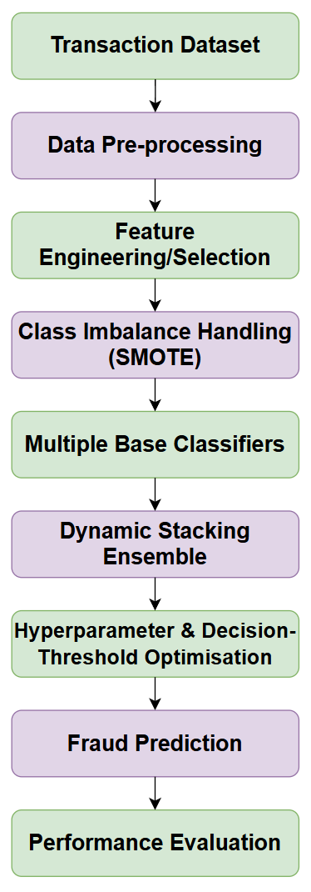

High-end Design of Project
Stage | Low-level process
1. Data Input | Load the NeurIPS 2022 bank-account fraud dataset from Kaggle
2. Pre-processing | Identify missing values, encode categorical variables and prepare numerical features
3. Feature Engineering | Transform and select relevant transaction or account characteristics
4. Imbalance Handling | Apply SMOTE to address severe class imbalance
5. Base Models | Train multiple diverse machine-learning classifiers
6. Ensemble Layer | Combine predictions through dynamic stacking
7. Optimisation | Tune model parameters and decision thresholds
8. Prediction | Classify observations as fraudulent or legitimate
9. Evaluation | Compare ensemble against individual baseline models
10. Output | Report fraud-detection performance and computational latency

Low-level Design Project
System Test Cases, Evidence of Manual/Automated testing
Test Case | Test Activity | Expected Result | Evidence
TC01 - Dataset Loading | Load the Kaggle fraud dataset into Python | Dataset loads successfully with expected records and features | Python output or screenshot
TC02 - Data Pre-processing | Check missing values, data types and categorical encoding | Data is cleaned and transformed without processing errors | Python output
TC03 - Class Imbalance | Measure class distribution before and after SMOTE | Minority class representation is increased appropriately | Class-distribution table or graph
TC04 - Model Training | Train individual baseline classifiers | Models train successfully and generate predictions | Training output or notebook
TC05 - Ensemble Prediction | Execute the dynamic stacking ensemble | Ensemble produces fraud or non-fraud predictions | Prediction output
TC06 - Performance Evaluation | Calculate F1-score, AUC-ROC, precision and recall | Performance metrics are generated successfully | Results table or confusion matrix
TC07 - False-Positive Testing | Assess legitimate transactions incorrectly classified as fraud | False-positive rate is measured and compared with baselines | Evaluation results
TC08 - Computational Testing | Measure model processing or prediction latency | Computational latency is recorded for comparison | Timing output

System Test Cases, Evidence of Manual/Automated testing
Risk assessment – Log, Register, and Map
Risk ID | Identified Risk | Likelihood | Impact | Initial Risk Level
R1 | Severe class imbalance may reduce detection of fraudulent cases | High | High | High
R2 | Data leakage during preprocessing or SMOTE may inflate model performance | Medium | High | High
R3 | Overfitting may reduce model generalisability | Medium | High | High
R4 | High false-positive rates may incorrectly flag legitimate transactions | Medium | High | High
R5 | Ensemble model may require excessive computational resources or processing time | Medium | Medium | Medium
R6 | Missing or inconsistent data may affect model performance | Medium | Medium | Medium
R7 | Model performance may vary because of temporal shifts in the dataset | Medium | High | High
R8 | Incorrect storage or handling of research data may create data-security concerns | Low | High | Medium

Risk Log
ID | Risk | Mitigation or Control | Residual Risk
R1 | Class imbalance | Apply SMOTE only to the training data and evaluate minority-class performance using F1, recall and AUC-ROC | Medium
R2 | Data leakage | Separate training and testing data before preprocessing and resampling | Low
R3 | Overfitting | Use validation procedures, baseline comparison and hyperparameter optimisation | Medium
R4 | False positives | Optimise decision thresholds and compare precision or false-positive performance against baseline models | Medium
R5 | Computational cost | Measure latency and optimise model parameters and computational processes | Medium
R6 | Data quality | Perform systematic data cleaning, missing-value checks and feature preprocessing | Low
R7 | Temporal shifts | Evaluate model performance carefully across available data characteristics and document limitations | Medium
R8 | Data security | Use the pre-anonymised dataset and secure password-protected storage accessible only to the researcher | Low

Risk Register
Probability ↓ | Impact → | 1 – Very Low | 2 – Low | 3 – Medium | 4 – High | 5 – Very High
5 – Very High
4 – High |  |  |  | R1
3 – Medium |  |  | R5, R6 | R2, R3, R4, R7
2 – Low |  |  |  | R8
1 – Very Low

Risk Map

3.10 Dataset source
The study will utilise the bank account fraud dataset which is obtained from Kaggle. The dataset is a publicly available secondary and pre-anonymised dataset which contains nearly 1 million bank account opening records and 30 features which are designed for representing realistic conditions of fraud detection which includes temporal variation and severe class imbalance. It is thereby suitable for evaluating and developing the proposed machine learning ensemble model without requiring direct participant recruitment or access to identifiable banking information.
GitHub Repository Link: https://github.com/gowrisettilalimanikanta8186-tech/BankingFinance

3.11 Data Analysis
Data analysis was performed in Python using the pandas and scikit-learn libraries, starting with ingesting and preprocessing the NeurIPS 2022 Bank Account Fraud Base dataset. Unlabeled features in some variants of the datasets were systematically removed to ensure consistency in the dimensions of all the datasets. The categorical features were one-hot encoded and then the data was split into a training set and test set using a 70/30 stratified split. Since the banking data is highly imbalanced with the number of fraud cases being very small, SMOTE was used only on the training set to create synthetic samples of the minority fraud class, with care taken to ensure no data leakage to the test set. After the data preparation, both Random Forest and XGBoost algorithms were trained as base classifiers and a dynamic Stacking Ensemble was trained using both Random Forest and XGBoost as base classifiers and a Logistic Regression meta-classifier. Precision, Recall, F1-Score, AUC-ROC, FPR and computational latency in seconds were used to evaluate these models on the Base test set. To test the robustness of the model to temporal and distributional changes, the pre-trained Stacking Ensemble was then tested on the remaining five variant datasets (Variants I-V). Categorical features of each variant were aligned and reindexed to match the exact column structure of the original Base training set before calculating inference metrics.

3.12 Ethics and ethics approval
The study has involved no direct human participants or primary data collection. It has used a secondary and publicly available pre-anonymised bank account fraud dataset which contains no personally identifiable information. As a result, the risks relating to informed consent, physical or emotional harm, participant privacy, and participant identification are not applicable. The dataset will be securely stored on password-protected storage which is accessible only to the researcher according to the stated data management requirements. The completed UREC2 Low Risk Human Participant Research Ethics form has confirmed that the study will not require additional ethical approval from external or NHS-related research ethics committees.

4. Results
A developed machine-learning pipeline was applied and tested on the Base test dataset as well as five variant datasets. By oversampling the minority (fraud) class, SMOTE managed to balance the training set to have around 70,000 transactions per class, which is close to the majority (legitimate) class and improved the fraud cases' representation in the training set. This is similar to the method used by Guterres et al. (2026), which uses SMOTE with ensemble classifiers to handle the problem of class imbalance, and Rajasekar et al. (2026), who employed SMOTE with machine learning classifiers for detecting fraud. XGBoost gave the best performance with an F1 score of 0.0576, an AUC-ROC of 0.8441 and a false-positive rate of 0.0020 while the Stacking Ensemble achieved an F1 score of 0.0546, an AUC-ROC of 0.7838 and a false-positive rate of 0.0027 on the Base dataset. Thus, the ensemble did not perform better than XGBoost, which shows that the use of ensembles of classifiers does not necessarily result in better prediction results. The result offers a valuable contrast with George et al. (2025), who identified hybrid ensemble frameworks as potential approaches that could be adapted for fraud detection.
In addition, the extremely low values of 0.0353 and 0.0485 for XGBoost and Stacking Ensemble, respectively, again reflect the challenge of recognizing fraudulent cases in highly imbalanced banking datasets. This is in line with the findings by Rajasekar et al. (2026) on the management of precision–recall trade-off using threshold and cost-sensitive approaches. Computational performance was also seen to be better for XGBoost in comparison to Stacking Ensemble, as XGBoost took 3.05 seconds to train while Stacking Ensemble took 118.86 seconds. This result confirms the notion raised by Sathupadi et al. (2025) that the more complex architectures used for fraud detection can be computationally heavy. The results indicate that ensemble complexity must be grounded on achievable gains in predictive performance, robustness and computational efficiency and should not be simply taken for granted that a more complex model will be superior to an effective individual basis classifier.

4.1 Implementation Evidence

Artefacts:
SMOTE Class Distribution
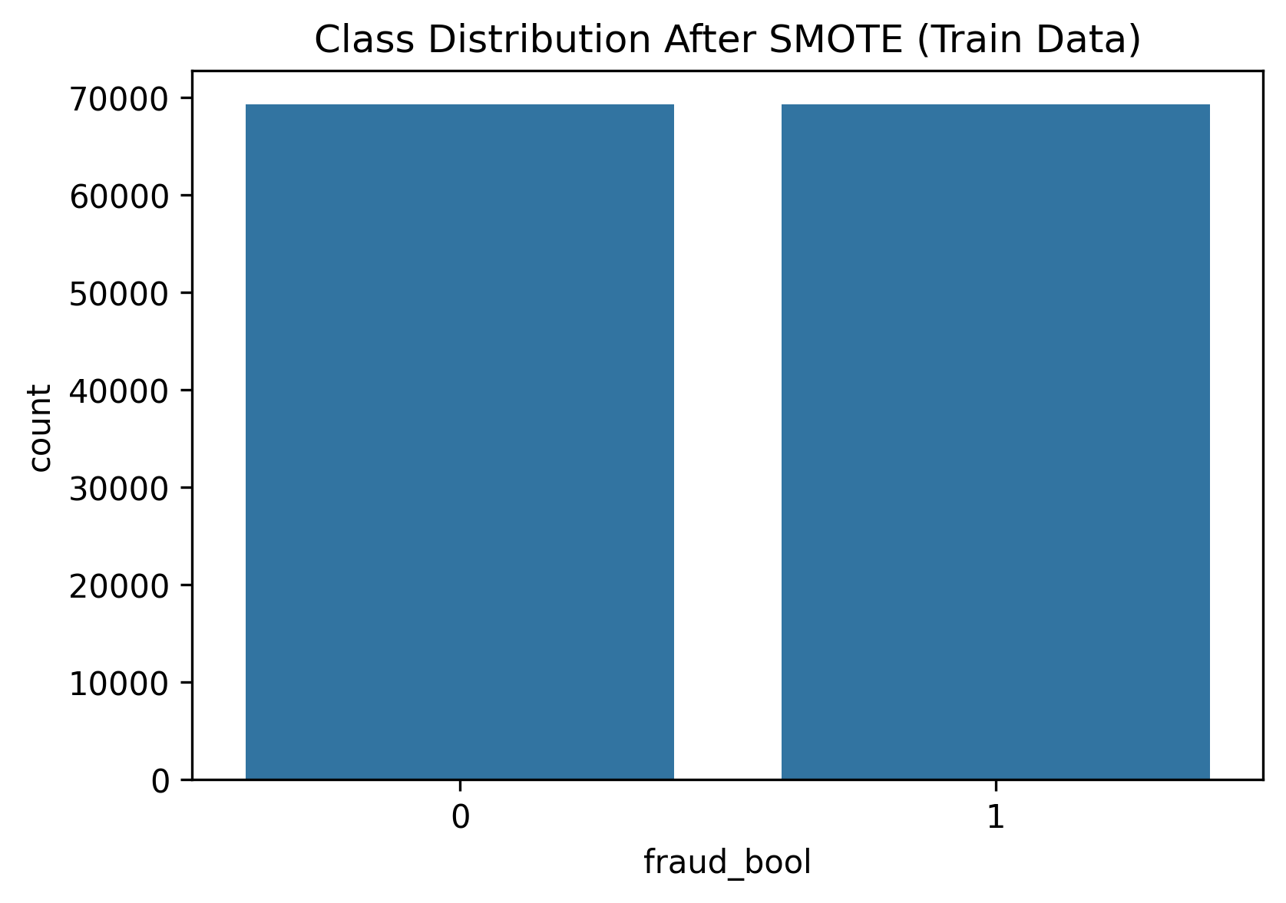
Figure 1: Class Distribution After SMOTE.

Model Performance on Base Dataset
Table 1: Model Performance on Base Dataset
Model | Precision | Recall | F1-Score | AUC-ROC | False Positive Rate | Train Time (s) | Infer Time (s)
Random Forest (Baseline) | 0.1034 | 0.0288 | 0.0451 | 0.8271 | 0.0026 | 39.94 | 0.63
XGBoost (Baseline) | 0.1571 | 0.0353 | 0.0576 | 0.8441 | 0.002 | 3.05 | 0.16
Stacking Ensemble | 0.1209 | 0.0353 | 0.0546 | 0.7838 | 0.0027 | 118.86 | 0.43

False Positive Analysis (Confusion Matrix)
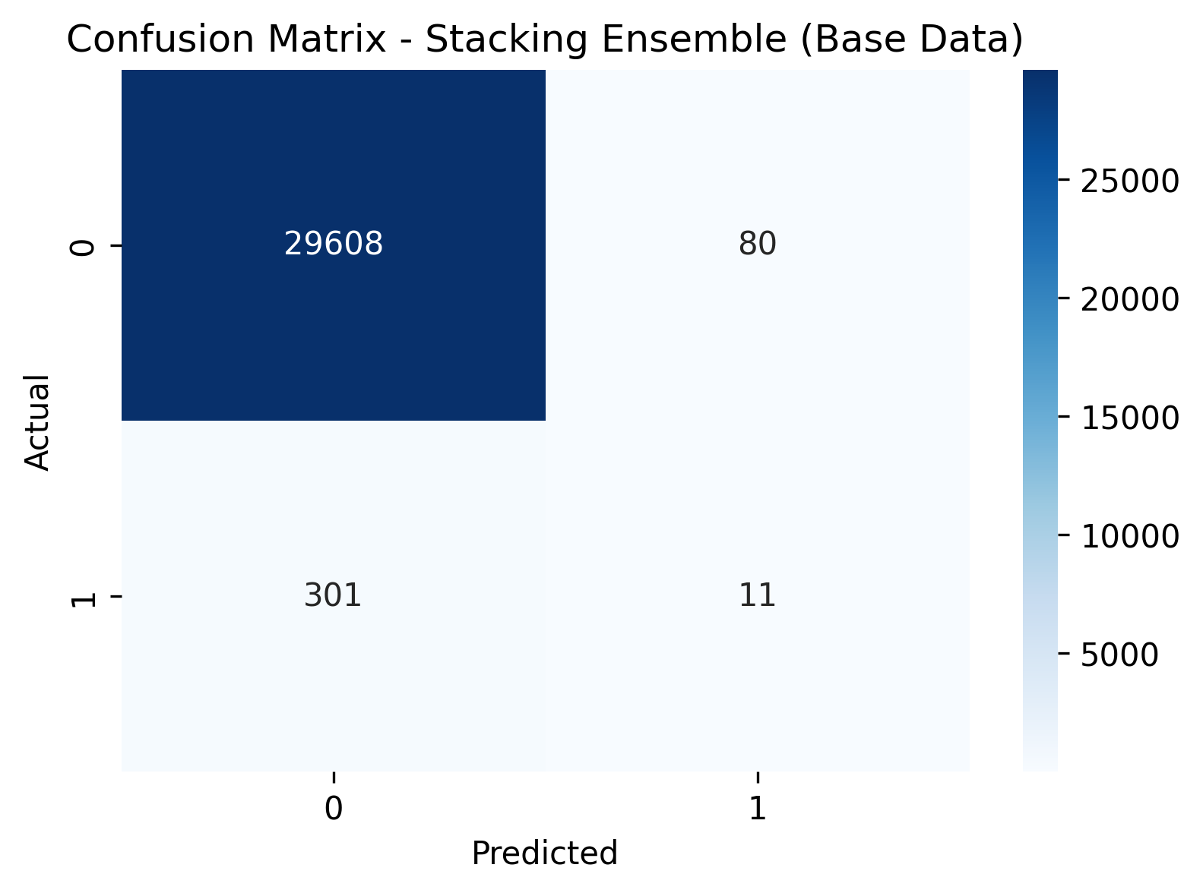
Figure 2: Stacking Ensemble Confusion Matrix.

Precision–Recall Analysis

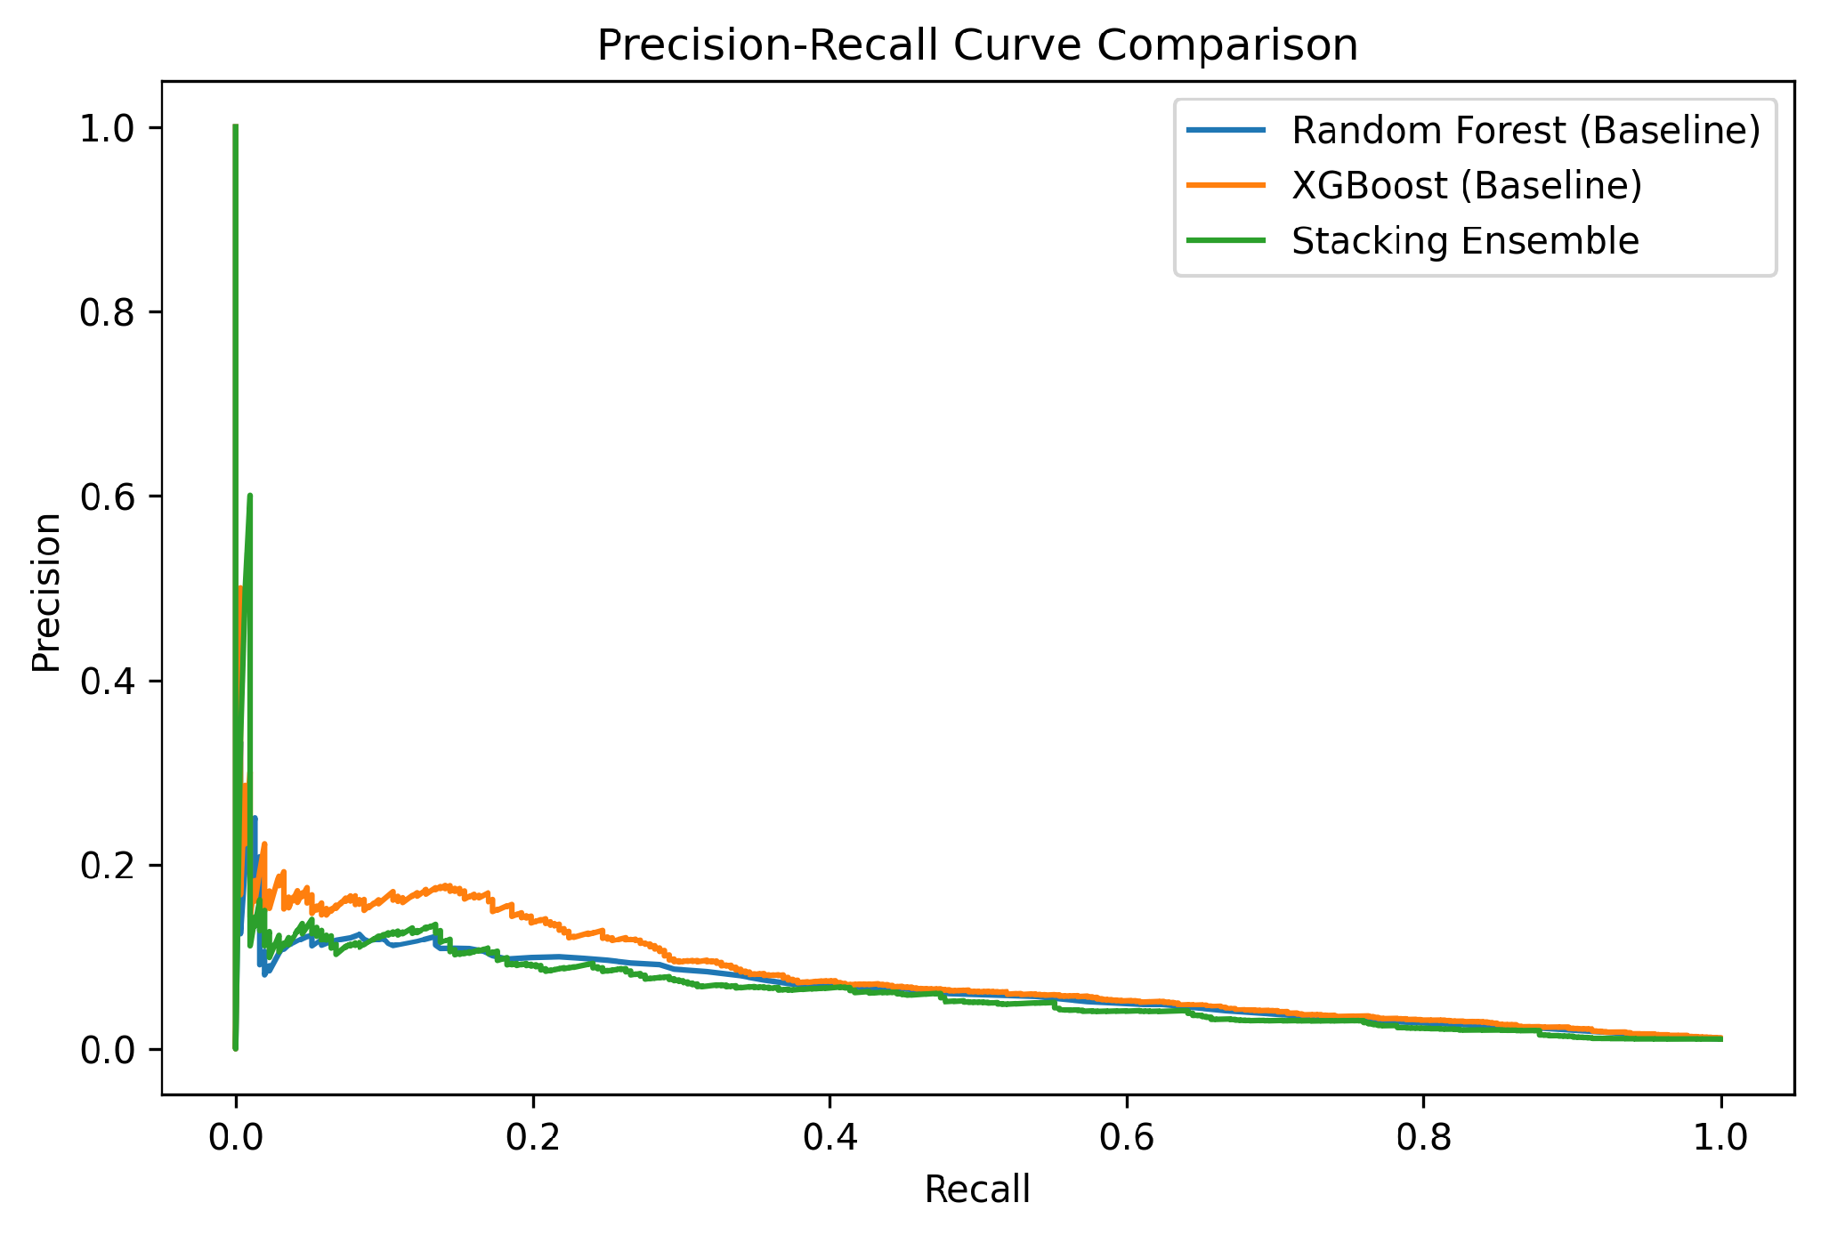
Figure 3: Precision–Recall Trade-off for the Evaluated Models.

Variant Robustness Testing
Table 2: Variant Performance.
Dataset | Precision | F1-Score | AUC-ROC | FPR
Variant I | 0.1971 | 0.0920 | 0.7641 | 0.0028
Variant II | 0.1902 | 0.1250 | 0.8084 | 0.0047
Variant III | 0.1642 | 0.1090 | 0.7735 | 0.0045
Variant IV | 0.1708 | 0.1164 | 0.8013 | 0.0047
Variant V | 0.1681 | 0.1174 | 0.7772 | 0.0049

5. Evaluation
Developed fraud-detection system was tested with respect to its technical requirements as follows: system acceptance testing, performance comparison and robustness testing. The study investigated if the pipeline was able to process the data required for these transactions, deal with class imbalance, train the selected models, make predictions and assess the fraud detection performance. The project was based on eight system tests: Loading Data Set, Preprocessing, SMOTE Implementing, Model Training, Ensemble Prediction, Performance Evaluation, False-Positive Testing and Computational Testing.
Evaluation evidence shows the core technical requirements met. The SMOTE method was able to create a balanced set of training classes, whereas the Random Forest, XGBoost and Stacking Ensemble produced values of specific predictions and performance measures. XGBoost demonstrated the best performance with the Base-dataset with an F1-score of 0.0576, AUC-ROC of 0.8441 and FPR of 0.0020. The Stacking Ensemble achieved an F1-score of 0.0546, AUC-ROC of 0.7838 and FPR of 0.0027. This means that the ensemble did not show any improvement compared to XGBoost on the Base dataset, which is an important drawback of the approach developed.
It was also shown to be robust under the five different datasets used for the testing. For the highest F1-score (0.1250), it was on Variant II and the other five variants had F1-scores ranging from 0.0920 to 0.1250. The computational assessment also revealed that XGBoost only needed 3.05 seconds to train model while the Stacking Ensemble took 118.86 seconds.
As the project utilized secondary, pre-anonymised data and not engaged in primary data collection there were no potential beneficiaries or human users. As such, evidence of user feedback, participation and consent forms are therefore not available. The system acceptance testing, objective model results and self-evaluation are therefore used to evaluate the system, while the lack of beneficiary validation is identified as one of limitations.

Evaluation Artefacts

System Acceptance Testing Results
Table 1: System Acceptance Testing Results
Test ID | Evaluation Activity | Expected Outcome | Evidence | Result
UAT-01 | Dataset loading | Dataset loads successfully | Python implementation | Passed
UAT-02 | Data preprocessing | Data is cleaned and transformed correctly | Preprocessing output | Passed
UAT-03 | SMOTE implementation | Minority class is appropriately balanced | SMOTE distribution figure | Passed
UAT-04 | Model training | Models successfully generate predictions | Model performance output | Passed
UAT-05 | Ensemble prediction | Stacking Ensemble generates fraud predictions | Confusion matrix | Passed
UAT-06 | Performance evaluation | Required performance metrics are generated | Results table | Passed
UAT-07 | False-positive testing | False-positive rate is measured | Confusion matrix/results | Passed
UAT-08 | Computational testing | Training and inference times are recorded | Timing results | Passed
These tests correspond to the eight system tests established in the project design.

Evaluation against Project Requirements
Table 2: Evaluation against Project Requirements.
Project Requirement | Evaluation Evidence | Outcome
Handle severe class imbalance | SMOTE balanced the training classes | Achieved
Train multiple classifiers | Random Forest and XGBoost implemented | Achieved
Develop Stacking Ensemble | Ensemble model successfully implemented | Achieved
Generate fraud predictions | Confusion matrix generated | Achieved
Measure predictive performance | Precision, Recall, F1 and AUC-ROC calculated | Achieved
Measure false positives | FPR calculated for models and variants | Achieved
Assess computational efficiency | Training and inference times recorded | Achieved
Assess robustness | Five variant datasets tested | Achieved

Comparative Model Evaluation
Table 3: Comparative Model Evaluation
Model | F1-Score | AUC-ROC | FPR | Training Time
Random Forest | 0.0451 | 0.8271 | 0.0026 | 39.94s
XGBoost | 0.0576 | 0.8441 | 0.0020 | 3.05s
Stacking Ensemble | 0.0546 | 0.7838 | 0.0027 | 118.86s
The results confirm that XGBoost provided the strongest Base-dataset performance and substantially lower training time.

Robustness Evaluation
Table 4: Robustness Evaluation
Dataset | Precision | F1-Score | AUC-ROC | FPR
Variant I | 0.1971 | 0.0920 | 0.7641 | 0.0028
Variant II | 0.1902 | 0.1250 | 0.8084 | 0.0047
Variant III | 0.1642 | 0.1090 | 0.7735 | 0.0045
Variant IV | 0.1708 | 0.1164 | 0.8013 | 0.0047
Variant V | 0.1681 | 0.1174 | 0.7772 | 0.0049
The variant results demonstrate that the Stacking Ensemble retained measurable performance under distributional and temporal changes.

6. Conclusion
The work in this project involved the creation and assessment of an ensemble machine learning algorithm for fraud detection in digital banking transactions, especially focusing on the improvement of the fraud-detection performance and minimizing false positives. The key steps of the project involved data preprocessing, handling the imbalanced class problem via SMOTE, training random forest and XGboost classifiers, creation of a Stacking Ensemble, and assessment of the classifiers using evaluation metrics such as F1-score, AUC-ROC, precision, recall, false-positive rate, and computational latency.
The first objective was accomplished by pre-processing the highly imbalanced transaction dataset and then using SMOTE just on the training data. This resulted in a much more balanced distribution of fraudulent transactions without any leakage effect into the test set. The second objective was achieved by developing the Stacking Ensemble with Logistic Regression as the meta-classifier and using Random Forest and XGBoost as the base classifiers. The third goal, related to optimisation of predictive performance and false-positive control, was partially achieved. The ensemble produced a low FPR, but it was not better than XGBoost on the Base dataset.
This result partly contradicts George et al. (2025), which emphasized the versatility and flexibility of hybrid ensemble methods, and shows that the complexity of an ensemble does not necessarily lead to better prediction performance. This low recall also reinforces the challenge of identifying minority fraud cases, and the importance of considering the precision–recall trade-off as highlighted by Rajasekar et al. (2026). Moreover, the training time of XGBoost was significantly less than Stacking Ensemble, echoing the computational issue of more advanced architectures mentioned by Sathupadi et al. (2025). However, robustness testing demonstrated that the performance of the Stacking Ensemble was still measurable in five different variant datasets, with the best F1 score being associated with Variant II, with a score of 0.1250. The results indicate that even if one can combine classifiers to get the best results, the combination should not sacrifice predictive ability, false positive control, robustness or computational efficiency.

7. Reference List
Manzoor, M.F. & Aslam, M.F. (2025). Enhancing banking fraud detection: Role of machine learning and deep learning methods. Premier Journal of Artificial Intelligence, 1(1). DOI: https://doi.org/10.70389/PJAI.100014
Naeem, W., Butt, M. A., & Javeid, U. (2026). Machine Learning-Based Fraud Detection Systems and Their Effectiveness in Reducing Cybersecurity Risks in Digital Banking. Social Science Review Archives, 4(2), 2553-2573. DOI: https://doi.org/10.70670/sra.v4i2.2344
Salami, I. A., Popoola, A. D., Gbadebo, M. O., Kolo, F. H. O., & Adesokan-Imran, T. O. (2025). AI-powered behavioural biometrics for fraud detection in digital banking: A next-generation approach to financial cybersecurity. Asian Journal of Research in Computer Science, 18(4), 473-494. DOI: https://doi.org/10.9734/ajrcos/2025/v18i4632
George, M. Z. H., Alam, M. K., & Hasan, M. T. (2025). Machine learning for fraud detection in digital banking: a systematic literature review REVIEW. arXiv preprint arXiv:2510.05167. DOI: https://doi.org/10.63125/913ksy63
Hanae, A. B. B. A. S. S. I., Abdellah, B. E. R. K. A. O. U. I., Saida, E. L. M. E. N. D. I. L. I., & Youssef, G. A. H. I. (2023). End-to-end real-time architecture for fraud detection in online digital transactions. International Journal of Advanced Computer Science and Applications, 14(6). https://www.researchgate.net/profile/Gahi-Youssef/publication/371970277_End-to-End_Real-time_Architecture_for_Fraud_Detection_in_Online_Digital_Transactions/links/64a0a90095bbbe0c6e06e6bc/End-to-End-Real-time-Architecture-for-Fraud-Detection-in-Online-Digital-Transactions.pdf
Sathupadi, K., Achar, S., Bhaskaran, S. V., Faruqui, N., & Uddin, J. (2025). BankNet: Real-time big data analytics for secure internet banking. Big Data and Cognitive Computing, 9(2), 24. DOI: https://doi.org/10.3390/bdcc9020024
Guterres, J. X., Widwaningtyas, T., & Zaeni, I. A. E. (2026). Fraud Identification in Online Financial Transactions Combining SMOTE and Ensemble Classifiers. Engineering, Technology & Applied Science Research, 16(2), 33323-33333. DOI: https://doi.org/10.48084/etasr.16615
Rajasekar, A., Patra, S., Dua, R., Rajmane, A., & Atulker, P. K. (2026). Machine Learning Applications In Fraud Detection For Digital Banking. INTERNATIONAL JOURNAL OF ADVANCES IN SIGNAL AND IMAGE SCIENCES, 1880-1895. http://www.xlescience.org/index.php/IJASIS/article/download/1102/432

Appendix A: AI declaration
This project complies with Level 2 (AI for shaping) configurations permitted under university academic conduct policies. AI tools were used to support the preparation of this presentation, including language refinement and proofreading, while the research, analysis, implementation, results, and conclusions were independently human-generated.

Appendix B: RESEARCH ETHICS PROFORMA
UREC2 RESEARCH ETHICS PROFORMA FOR STUDENTS UNDERTAKING LOW RISK PROJECTS WITH HUMAN PARTICIPANTS

This form is designed to help students and their supervisors to complete an ethical scrutiny of proposed research. The University Research Ethics Policy (www.shu.ac.uk/research/excellence/ethics-and-integrity/policies) should be consulted before completing this form. The initial questions are there to check that completion of the UREC 2 is appropriate for this study. The final responsibility for ensuring that ethical research practices are followed rests with the supervisor for student research.

Note that students and staff are responsible for making suitable arrangements to ensure compliance with the General Data Protection Act (GDPR). This involves informing participants about the legal basis for the research, including a link to the University research data privacy statement and providing details of who to complain to if participants have issues about how their data was handled or how they were treated (full details in module handbooks). In addition, the act requires data to be kept securely and the identity of participants to be anonymised. They are also responsible for following SHU guidelines about data encryption and research data management. Guidance can be found on the SHU Ethics Website www.shu.ac.uk/research/excellence/ethics-and-integrity

Please note that it is mandatory for all students to only store data on their allotted networked F drive space and not on individual hard drives or memory sticks etc.

The present form also enables the University and College to keep a record confirming that research conducted has been subjected to ethical scrutiny.

The form must be completed by the student and the supervisor and independently reviewed by a second reviewer or module leader (additional guidance can be obtained from your College Research Ethics Chair). In all cases, it should be counter-signed and kept as a record showing that ethical scrutiny has occurred. Some courses may require additional scrutiny. Students should retain a copy for inclusion in their research projects, and a copy should be uploaded to the relevant module Blackboard site.

Please note that it may be necessary to conduct a health and safety risk assessment for the proposed research. Further information can be obtained from the University’s Health and Safety Website https://sheffieldhallam.sharepoint.com/sites/3069/SitePages/Risk-Assessment.aspx

SECTION A

- Checklist questions to ensure that this is the correct form:

Health Related Research within the NHS, or His Majesty’s Prison and Probation Service (HMPPS), or with participants unable to provide informed consent check list.

Question | Yes/No
Does the research involve?
- Patients recruited because of their past or present use of the NHS | No
- Relatives/carers of patients recruited because of their past or present use of the NHS | No
- Access to NHS staff, premises, or resources | No
- Access to data, organs, or other bodily material of past or present NHS patients | No
- Foetal material and IVF involving NHS patients | No
- The recently dead in NHS premises | No
- Prisoners or others within the criminal justice system recruited for health-related research | No
- Police, court officials, prisoners, or others within the criminal justice system | No
- Participants who are unable to provide informed consent due to their incapacity even if the project is not health related | No
- Is this an NHS research project, service evaluation or audit?  For NHS definitions please see the following website http://www.hra.nhs.uk/documents/2013/09/defining-research.pdf | No

If you have answered YES to any of the above questions, then you MUST consult with your supervisor to obtain research ethics from the appropriate institution outside the university. This could be from the NHS or Her Majesty’s Prison and Probation Service (HMPPS) under their independent Research Governance schemes. Further information is provided below. https://www.myresearchproject.org.uk/

- Checks for Research with Human Participants

Question | Yes/No
- Will any of the participants be vulnerable?  Note: Vulnerable people include children and young people, people with learning disabilities, people who may be limited by age or sickness, pregnancy, people researched because of a condition they have, etc. See full definition on ethics website in the document Code of Practice for Researchers Working with Vulnerable Populations (under the Supplementary University Polices and Good Research Practice Guidance) | No
- Are drugs, placebos, or other substances (e.g., food substances, vitamins) to be administered to the study participants or will the study involve invasive, intrusive, or potentially harmful procedures of any kind? | No
- Will tissue samples (including blood) be obtained from participants? | No
- Is pain or more than mild discomfort likely to result from the study? | No
- Will the study involve prolonged or repetitive testing? | No
- Is there any reasonable and foreseeable risk of physical or emotional harm to any of the participants?  Note: Harm may be caused by distressing or intrusive interview questions, uncomfortable procedures involving the participant, invasion of privacy, topics relating to highly personal information, topics relating to illegal activity, or topics that are anxiety provoking, etc. | No
- Will anyone be taking part without giving their informed consent? | No
- Is the research covert?  Note: ‘Covert research’ refers to research that is conducted without the knowledge of participants. | No
- Will the research output allow identification of any individual who has not given their express consent to be identified? | No

If you have answered YES to any of these questions you are REQUIRED to complete and submit a UREC3 or UREC4 form. Your supervisor will advise. If you have answered NO to all these questions, then proceed with this form (UREC2).

- General Project Details

Details
Name of student |  | Lali Manikanta Gowrisetti
SHU email address |  | LaliManikanta.M.Gowrisetti@student.shu.ac.uk
Department/College |  | MSc Data Analytics with Banking and Finance
Name of supervisor |  | Dr. Jumoke Popoola
Supervisor’s email address |  | J.Popoola@shu.ac.uk
Title of proposed research |  | Building an ML-based Ensemble Model for Fraud Detection in Digital Banking Transactions
Proposed start date |  | 12/06/2026
Proposed end date |  | 10/09/2026
Background to the study and the rationale (reasons) for undertaking the research (500 words) |  | The contemporary financial ecosystem has gone through a paradigm shift which has been defined by an expensive and rapid transition towards channels of digital banking. Even though this digital evolution has accelerated the velocity and volume of transactions vastly, it has also opened new vulnerabilities simultaneously, and it has led to an unprecedented surge in sophisticated financial cyber threats. The traditional mechanisms of fraud detection have relied typically on single-algorithm architectures or rule-based and rigid systems. The new literature has indicated that such conventional configurations are increasingly obsolete for countering the highly adaptive and modern fraud patterns. Single classifiers have often struggled with the complicated, nonlinear, multidimensional variables which are present in the banking data of the modern day, and this has resulted in compromised accuracy of detection. As a result, banking institutions have a multifaceted challenge where the high financial losses from undetected fraudulent activities are growing, and there is also widespread operational friction which is caused by false positives, which can disrupt the legitimate transactions done by customers.  The main rationale for this research is seated in the operational advantages which are offered by methodologies of ensemble machine learning. Instead of depending on a stand-alone predictive model, an ensemble framework can combine the diversified base learners strategically. Research has demonstrated that ensemble architectures can improve overall accuracy of classification significantly while also simultaneously mitigating the incidence of costly false alarms.
Aims & research question(s) | To design, develop, evaluate, and implement a machine learning-based ensemble model that enhances fraud detection precision and minimizes false positives in high-velocity and diverse digital banking transactions. Objectives:  - To identify the recent trends and challenges in fraud detection for high-velocity digital banking transactions, with particular emphasis on class imbalance, missing data, and evolving fraud patterns.  - To examine the effectiveness of machine learning-based ensemble techniques in improving fraud detection performance compared with individual machine learning algorithms.  - To assess the impact of feature engineering, data pre-processing, and ensemble learning strategies on improving fraud detection precision while reducing false positives in digital banking transactions.  - To determine the effectiveness of the proposed ensemble model by comparing its performance with baseline machine learning algorithms using evaluation metrics such as F1-score, AUC-ROC, precision, recall, and computational latency  How can a dynamically optimised machine learning-based ensemble model improve the accuracy of fraud detection and also reduce the rates of false positives in high-velocity transactions of digital banking?
Methods to be used for:  - Recruitment of participants  - Data collection  - Data analysis | No, human participants will be recruited. The study uses only publicly available,pre-existing,anonymized secondary datasets.  https://www.kaggle.com/datasets/sgpjesus/bank-account-fraud-dataset-neurips-2022  The data will go through a thorough computational analysis process.  Study will utilise the open-source and secondary bank account fraud dataset suite from NeurIPS 2022, accessed via Kaggle. This tabular dataset comprises one million anonymised account-opening instances along with 30 realistic features incorporated with severe class imbalance and temporal shifts for mimicking the high-velocity banking noise. Data analysis will start by addressing the skewed target class by using SMOTE oversampling. After feature preprocessing for handling missing values and encoding, multiple diverse base machine learning classifiers will be incorporated into a dynamically stacked ensemble architecture for predicting fraud. Model performance will be evaluated comprehensively by using AUC-ROC, F1-score, and operational latency metrics.
Outline the nature of the data held, details of anonymisation, storage and disposal procedures as required. | The research will utilise a public, secondary, and pre-anonymised Kaggle dataset which contains tabular bank account opening data with no personally identifiable information. The collected data will be stored securely on password-protected storage which is accessible only to the primary researcher.

4. Research in External Organisations

Question | Yes/No
- Will the research involve working with/within an external organisation (e.g., school, business, charity, museum, government department, international agency, etc.)? | No
- If you answered YES to question 1, do you have granted access to conduct the research from the external organisation?  If YES, students please show evidence to your supervisor. You should retain this evidence safely. | N/A
- If you do not have permission for access is this because:  - you have not yet asked  - you have asked and not yet received an answer  - you have asked and been refused access  Note: You will only be able to start the research when you have been granted access. | N/A

- Research with Products and Artefacts

Question | Yes/No
1. Will the research involve working with copyrighted documents, films, broadcasts, photographs, artworks, designs, products, programs, databases, networks, processes, existing datasets, or secure data? | Yes
2. If you answered YES to question 1, are the materials you intend to use in the public domain?  Notes: ‘In the public domain’ does not mean the same thing as ‘publicly accessible’.  - Information which is 'in the public domain' is no longer protected by copyright (i.e., copyright has either expired or been waived) and can be used without permission.  - Information which is 'publicly accessible' (e.g., TV broadcasts, websites, artworks, newspapers) is available for anyone to consult/view. It is still protected by copyright even if there is no copyright notice. In UK law, copyright protection is automatic and does not require a copyright statement, although it is always good practice to provide one. It is necessary to check the terms and conditions of use to find out exactly how the material may be reused etc.  If you answered YES to question 1, be aware that you may need to consider other ethics codes. For example, when conducting Internet research, consult the code of the Association of Internet Researchers; for educational research, consult the Code of Ethics of the British Educational Research Association. | Yes
3. If you answered NO to question 2, do you have explicit permission to use these materials as data?  If YES, please show evidence to your supervisor. | Yes, my supervisor has approved my data and it is publicly accessible and has permission to be used.
4. If you answered NO to question 3, is it because:  A. you have not yet asked permission  B. you have asked and not yet received and answer  C. you have asked and been refused access.  Note: You will only be able to start the research when you have been granted permission to use the specified material. | N/A

SECTION B

HEALTH AND SAFETY RISK ASSESSMENT FOR THE RESEARCHER
- Does this research project require a health and safety risk assessment for the procedures to be used? (Discuss this with your supervisor)

Yes
No

If YES the completed Health and Safety Risk Assessment form should be attached. A standard risk assessment form can be generated through the Awaken system (https://shu.awaken-be.com). Alternatively if you require more specific risk assessment, e.g. a COSHH, attach that instead.

- Will the data be collected fully online (no face-to-face contact with participants)?

Yes (See the safety guidance for online research and go to question 7b)
No (Go to question 3)

- Will the proposed data collection take place on campus?

Yes (Please answer questions 5 to 8)
No (Please complete all questions and consult with your supervisor))

- Where will the data collection take place?
(Tick as many as apply if data collection will take place in multiple venues)

 | Location | Please specify
 | Researcher's Residence
 | Participant's Residence
 | Education Establishment
 | Other e.g., business/voluntary organisation, public venue
 | Outside UK

- How will you travel to and from the data collection venue?

On foot By car Public Transport
Other (Please specify)
Please outline how you will ensure your personal safety when travelling to and from the data collection venue.
Traveling will not be needed in this research for data collection

- How will you ensure your own personal safety whilst at the research venue?

The research venue will be the researcher’s residence, and thereby there will be no danger to the personal safety of the researcher.

- Are there any potential risks to your health and wellbeing associated with either (a) the venue where the research will take place and/or (b) the research topic itself?

None that I am aware of
Yes (Please outline below including steps taken to minimise risk)

² Safety guidance for online research includes information on how to set up online surveys and/or conduct online interviews/focus groups. These guidelines can be found in BB. Please check with your supervisor/module leader.

N/A – no risks identified.

- If you are carrying out research off-campus, you must ensure that each time you go out to collect data you ensure that someone you trust knows where you are going (without breaching the confidentiality of your participants), how you are getting there (preferably including your travel route), when you expect to get back, and what to do should you not return at the specified time.

Please outline here the procedure you propose using to do this.

N/A – no off-campus data collection will take place.

Insurance Check

The University’s standard insurance cover will not automatically cover research involving any of the following:

i) Participants under 5 years old
ii) Pregnant women
iii) 5000 or more participants
iv) Research being conducted in an overseas country
v) Research involving aircraft and offshore oil rigs
vi) Nuclear research
vii) Any trials/medical research into Covid 19

If your proposals do involve any of the above, please contact the Insurance Manager directly (fin-insurancequeries-mb@exchange.shu.ac.uk) to discuss this element of your project.

Adherence to SHU Policy and Procedures

Ethics sign-off
Personal statement
I can confirm that:
- I have read the Sheffield Hallam University Research Ethics Policy and Procedures
- I agree to abide by its principles.
Student
Name: Lali Manikanta Gowrisetti | Date: 23/07/2026

Signature:

Supervisor ethical sign-off
I can confirm that completion of this form has not identified the need for ethical approval by the TPREC/CREC or an NHS, Social Care, or other external REC. The research will not commence until any approvals required under Sections 4 & 5 have been received and any necessary health and safety measures are in place.
Name: Dr. Jumoke Popoola | Date: 23/07/2026
Signature: 
Independent Reviewer ethical sign off

Name: | Date:
Signature:

Please ensure that you have attached all relevant documents. Your supervisor must approve them before you start data collection:

Documents | Yes | No | N/A
Research proposal if prepared previously
Any recruitment materials (e.g., posters, letters, emails, etc.)
Participant information sheet
Participant consent form
Details of measures to be used (e.g., questionnaires, etc.)
Outline interview schedule / focus group schedule
Debriefing materials
Health and Safety Risk Assessment Form

Appendix C:

PUBLICATION PROCEDURE FORM
In this module, while you create your own research question or topic area, your supervisor makes a significant intellectual contribution to this work as the research progresses. Your supervisor will make the decision on whether your work merits publication based on the quality of the work you have produced. Your supervisor will co-author the paper for publication with you and your supervisor will both be listed as authors. You are required to sign the declaration below to confirm that you understand and will follow this procedure.
Declaration:
I LALI MANIKANTA GOWRISETTI confirm that I understand will comply with the Publication Procedure outlined in the Module Handbook and the Blackboard Site.

Student: |   Signature | Date 07-09-2026
Supervisor: | Signature  | Date 07-09-2026

Appendix D: Code Script

import pandas as pd
import numpy as np
import matplotlib.pyplot as plt
import seaborn as sns
from sklearn.model_selection import train_test_split
from sklearn.ensemble import RandomForestClassifier, StackingClassifier
from sklearn.linear_model import LogisticRegression
from xgboost import XGBClassifier
from sklearn.metrics import confusion_matrix, roc_auc_score, f1_score, precision_score, recall_score, precision_recall_curve
from imblearn.over_sampling import SMOTE
from docx import Document
from docx.shared import Inches
import time
import os
import gc

doc = Document()
doc.add_heading('Fraud Detection Model Analysis Results', 0)

sample_frac = 0.1
base_file = 'Base.csv'
variant_files = ['Variant I.csv', 'Variant II.csv', 'Variant III.csv', 'Variant IV.csv', 'Variant V.csv']

def add_plot(doc, fname, title):
plt.savefig(fname, bbox_inches='tight', dpi=300)
doc.add_heading(title, level=2)
doc.add_picture(fname, width=Inches(6.0))
os.remove(fname)
plt.clf()

df = pd.read_csv(base_file).sample(frac=sample_frac, random_state=42)
drop_c = ['x1', 'x2']
df = df.drop(columns=[c for c in drop_c if c in df.columns])
X = df.drop(columns=['fraud_bool'])
y = df['fraud_bool']
X_enc = pd.get_dummies(X)
train_cols = X_enc.columns
X_tr, X_te, y_tr, y_te = train_test_split(X_enc, y, test_size=0.3, random_state=42, stratify=y)

plt.figure(figsize=(6,4))
sns.countplot(x=y_tr)
add_plot(doc, 'pre.png', 'Class Imbalance Before SMOTE')

sm = SMOTE(random_state=42)
X_tr_sm, y_tr_sm = sm.fit_resample(X_tr, y_tr)
plt.figure(figsize=(6,4))
sns.countplot(x=y_tr_sm)
add_plot(doc, 'post.png', 'Class Imbalance After SMOTE')
del df, X, X_enc, X_tr, y_tr
gc.collect()

models = {
'RF': RandomForestClassifier(random_state=42, n_jobs=-1),
'XGB': XGBClassifier(random_state=42, eval_metric='logloss')
}
est = [
('rf', RandomForestClassifier(n_estimators=50, random_state=42, n_jobs=-1)),
('xgb', XGBClassifier(n_estimators=50, random_state=42, eval_metric='logloss'))
]
models['Ensemble'] = StackingClassifier(
estimators=est,
final_estimator=LogisticRegression(),
n_jobs=-1
)

res = []
trained = {}
for name, clf in models.items():
t0 = time.time()
clf.fit(X_tr_sm, y_tr_sm)
t_train = time.time() - t0
t1 = time.time()
preds = clf.predict(X_te)
probs = clf.predict_proba(X_te)[:, 1]
t_inf = time.time() - t1
tn, fp, fn, tp = confusion_matrix(y_te, preds).ravel()
res.append({
'Model': name,
'Precision': precision_score(y_te, preds),
'Recall': recall_score(y_te, preds),
'F1-Score': f1_score(y_te, preds),
'AUC-ROC': roc_auc_score(y_te, probs),
'FPR': fp / (fp + tn),
'Train Time': round(t_train, 2),
'Infer Time': round(t_inf, 2)
})
trained[name] = clf
res_df = pd.DataFrame(res)
doc.add_heading('Base Dataset Metrics', level=2)
table = doc.add_table(rows=1, cols=len(res_df.columns))
table.style = 'Table Grid'
cells = table.rows[0].cells
for i, col in enumerate(res_df.columns):
cells[i].text = col
for _, row in res_df.iterrows():
r_cells = table.add_row().cells
for i, val in enumerate(row):
r_cells[i].text = str(round(val, 4)) if isinstance(val, float) else str(val)

preds_ens = trained['Ensemble'].predict(X_te)
cm = confusion_matrix(y_te, preds_ens)
plt.figure(figsize=(6,4))
sns.heatmap(cm, annot=True, fmt='d', cmap='Blues')
add_plot(doc, 'cm.png', 'Confusion Matrix')
plt.figure(figsize=(8,5))
for name, clf in trained.items():
probs = clf.predict_proba(X_te)[:, 1]
prec, rec, _ = precision_recall_curve(y_te, probs)
plt.plot(rec, prec, label=name)
plt.legend()
add_plot(doc, 'pr.png', 'PR Curve')
del X_tr_sm, y_tr_sm, X_te, y_te
gc.collect()

doc.add_heading('Variant Tests', level=1)
ens = trained['Ensemble']
for v in variant_files:
if not os.path.exists(v):
continue
df_v = pd.read_csv(v).sample(frac=sample_frac, random_state=42)
df_v = df_v.drop(columns=[c for c in drop_c if c in df_v.columns])
X_v = df_v.drop(columns=['fraud_bool'])
y_v = df_v['fraud_bool']
X_v_enc = pd.get_dummies(X_v).reindex(columns=train_cols, fill_value=0)
p_v = ens.predict(X_v_enc)
prob_v = ens.predict_proba(X_v_enc)[:, 1]
tn, fp, fn, tp = confusion_matrix(y_v, p_v).ravel()
doc.add_heading(v, level=2)
doc.add_paragraph(f"F1: {f1_score(y_v, p_v):.4f}")
doc.add_paragraph(f"AUC: {roc_auc_score(y_v, prob_v):.4f}")
doc.add_paragraph(f"Precision: {precision_score(y_v, p_v):.4f}")
doc.add_paragraph(f"FPR: {fp / (fp + tn):.4f}")
del df_v, X_v, X_v_enc, y_v
gc.collect()
doc.save('results.docx')

Appendix E: Research project plan/Gannt chart
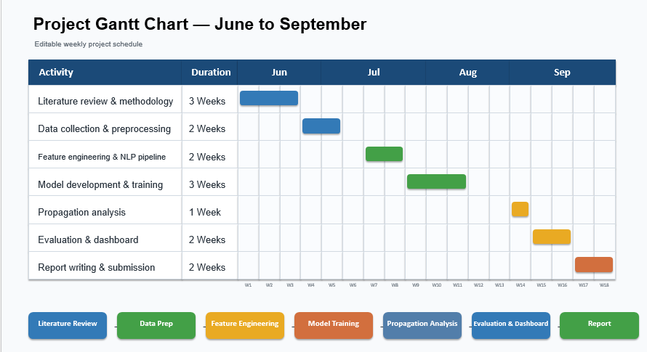

Appendix F: GitHub Repository Link
https://github.com/gowrisettilalimanikanta8186-tech/BankingFinance

College of Social Sciences and Arts - Dr. Antonia Ypsilanti (a.ypsilanti@shu.ac.uk ) College of Business, Technology and Engineering - Dr. Tony Lynn (t.lynn@shu.ac.uk ) College of Health, Wellbeing and Life Sciences - Dr. Nikki Jordan-Mahy (n.jordan-mahy@shu.ac.uk )
It is mandatory to attach the Participant Information Sheet (PIS)
It is mandatory to attach a Participant Consent Form, unless it is embedded in an online survey, in which case your supervisor must approve it before you start data collection

